14.23: a) The displaced fluid must weigh more than the object, so 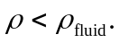 b) If the ship does not leak, much of the water will be displaced by air or cargo, and the average density of the floating ship is less than that of water. c) Let the portion submerged have volume V, and the total volume be 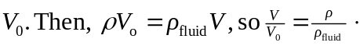 The fraction above the fluid is then 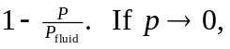 the entire object floats, and if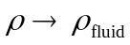, none of the object is above the surface. d) Using the result of part (c),

